Carissa Ying Geok Teng (A0205190R/E0425113)

1i)

Fluents

Vans: V1, V2, …, Vn

Grid: s0, s1, …, sg

Package: P1, P2, …, Pk

Direction: up, down, left, right

Predicates

Van(v), Grid(s), Package(p), Direction(d) tells what type each fluent is.

At(o, s) tells if a van or package, o, is at a grid location, s.

Available(s) tells if a grid location is empty.

Facing(v, d) tells if van, v is facing a direction, d.

FaceLeft(d1, d2), FaceRight(d1, d2) tells if direction d2 is the new direction to face if a left or right is taken from d1.

Left(a, b, d), Right(a, b, d), Front(a, b, d) tells if given a specific direction, d, to face, is grid location b to the left, right, or front of a.

Carrying(v, p) tells if a van, v is carrying a package, p.

Full(v) tells if a van cannot carry any more packages.

1ii)

Primitive actions

Action: TurnLeft(v, from, to, d1, d2)

Precond: Van(v) ^ Grid (from) ^ Grid(to) ^ Direction(d1) ^ Direction(d2) ^ At(v, from) ^ Available(to) ^ Facing(v, d1) ^ Left(from, to, d1) ^ FaceLeft(d1, d2)

Effect: ~Available(to) ^ Available(from) ^ ~At(v, from) ^ At(v, to) ^ ~Facing(v, d1) ^ Facing(v, d2)

Action: TurnRight(v, from, to, d1, d2)

Precond: Van(v) ^ Grid (from) ^ Grid(to) ^ Direction(d1) ^ Direction(d2) ^ At(v, from) ^ Available(to) ^ Facing(v, d1) ^ Right(from, to, d1) ^ FaceRight(d1, d2)

Effect: ~Available(to) ^ Available(from) ^ ~At(v, from) ^ At(v, to) ^ ~Facing(v, d1) ^ Facing(v, d2)

Action: GoForward(v, from, to, d)

Precond: Van(v) ^ Grid (from) ^ Grid(to) ^ Direction(d) ^ At(v, from) ^ Available(to) ^ Facing(v, d) ^ Front(from, to, d)

Effect: ~Available(to) ^ Available(from) ^ ~At(v, from) ^ At(v, to)

Action: Load(p, v, s)

Precond: Van(v) ^ Package(p) ^ Grid(s) ^ ~Full(v) ^ At(v, s) ^ At(p, s)

Effect: ~At(p, s) ^ Carrying(v, p) ^ Full(v)

Action: Unload(p, v, s)

Precond: Van(v) ^ Package(p) ^ Grid(s) ^ At(v, s) ^ Carrying(v, p)

Effect: At(p, s) ^ ~Carrying(v, p) ^ ~Full(v)

High Level Actions

Action: DeliverAllPackages()

Action: DeliverPackage(p, start, end)

Precond: At(p, start)

Action: Drive(v, start, end)

Precond: At(v, start)

1iii)

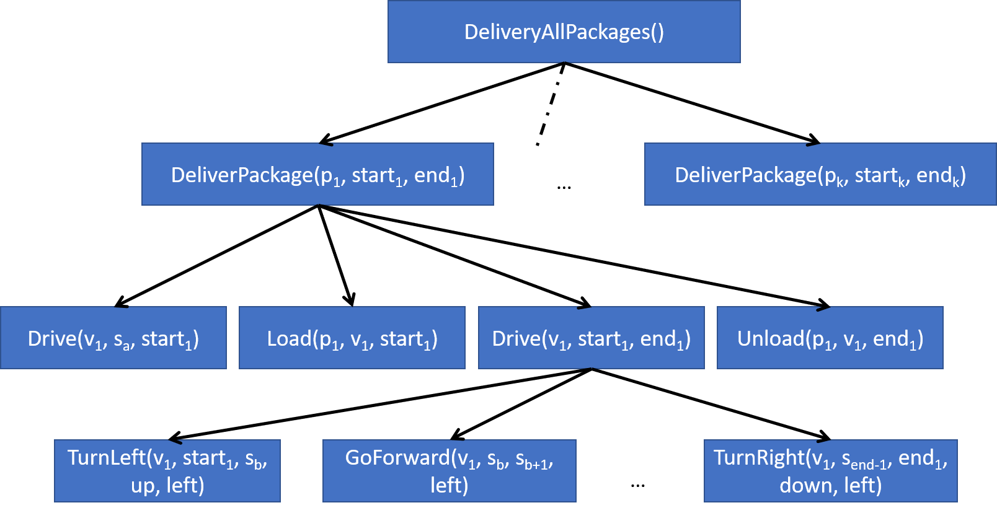

2)

EU(Game) =

= 0.5­1(21) + 0.52(22) + 0.53(23) + …

= 1 + 1 + 1 + …

= ∞

3)

Assuming if a move is invalid, the agent will stay in the same place,

P(4,3) = P(Right, Right, Up, Up, Right) + P(Up, Up, Right, Right, Right)

= (0.8\*0.8\*0.1\*0.8\*0.1) + (0.1\*0.1\*0.8\*0.1\*0.1)

= 0.0052

P(4,2) = P(Right, Right, Right, Up) + P(Right, Right, Up, Right) + P(Down, Right, Right, Right, Up) + P(Down, Right, Right, Up, Right) + P(Right, Down, Right, Right, Up) + P(Right, Down, Right, Up, Right) + P(Right, Up, Right, Right, Up) + P(Right, Up, Right, Up, Right) + P(Right, Right, Down, Right, Up) + P(Right, Right, Down, Up, Right) + P(Right, Right, Right, Right, Up) + P(Right, Right, Up, Left, Right)

= (0.8\*0.8\*0.8\*0.8) + (0.8\*0.8\*0.1\*0.1) + (0.1\*0.8\*0.8\*0.1\*0.8) + (0.1\*0.8\*0.8\*0.8\*0.1) + (0.8\*0.1\*0.8\*0.1\*0.8) + (0.8\*0.1\*0.8\*0.8\*0.1) + (0.8\*0.1\*0.8\*0.1\*0.8) + (0.8\*0.1\*0.8\*0.8\*0.1) + (0.8\*0.8\*0.1\*0.1\*0.8) + (0.8\*0.8\*0.1\*0.8\*0.1) + (0.8\*0.8\*0.8\*0.1\*0.8) + (0.8\*0.8\*0.1\*0.1\*0.1)

= 0.49856